**WEEKLY LOG**

**(every Sunday)**



**Sprint 1 (4.11)**

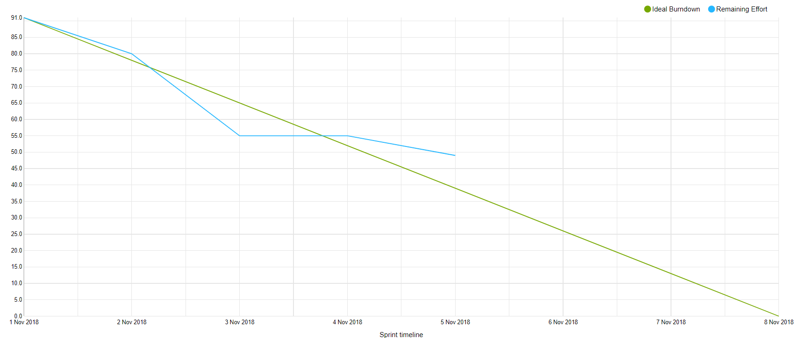

**What is done:**

* Database server
* Communication protocol (Search/Advanced search)
* Bookstore/Library implementation of model
* Activity diagram searching
* Class diagram : model, bookstore, library
* EER diagram : database book
* Database structure for books
* Domain and Logical model of book
* Search engine on database server

**What is in progress:**

* Class diagram : book service
* Book service redirecting and gathering book query
* GUI : search page (main page)
* GUI : showing results on web site
* Library/Bookstore connect to database
* Library expose REST for searching the book (just tests are missing)

**Sprint 2 (11.11)**

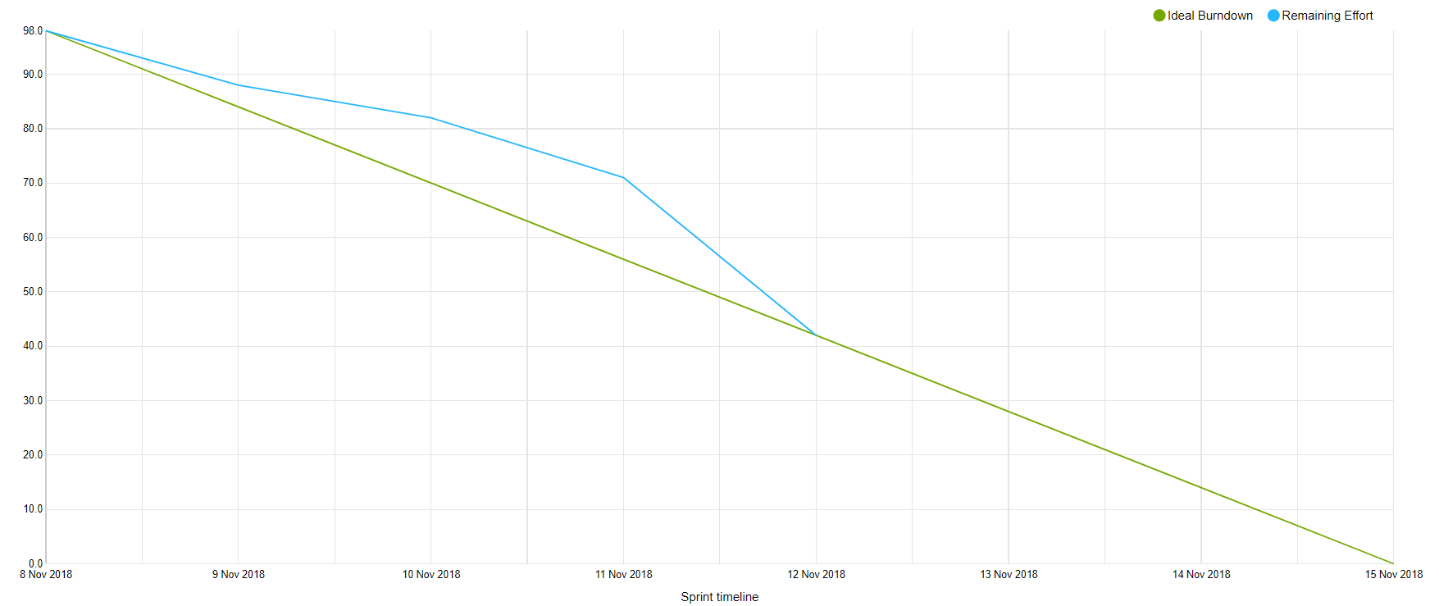

**What is done:**

* Class diagram : database
* GUI : showing result of search
* Use cases
* Database : availability
* Library CRUD
* Library CRUD test
* Class diagram (Library) updated
* Doc : add json examples to communication
* Database server : book details query
* Book service : book details
* Configuration of travis for C#
* Hibernate update for database schema

**What is in progress:**

* Bookstore CRUD
* Bookstore CRUD test
* Set up deploy
* GUI in progress

**New tasks:**

* Library database connection update
* Bookstore database connection update
* Database connection : handle details volumes
* Book service : handle details
* Library : create detailed book
* Library: book details -> read request
* Library: book details test

**Sprint 3 (18.11)**

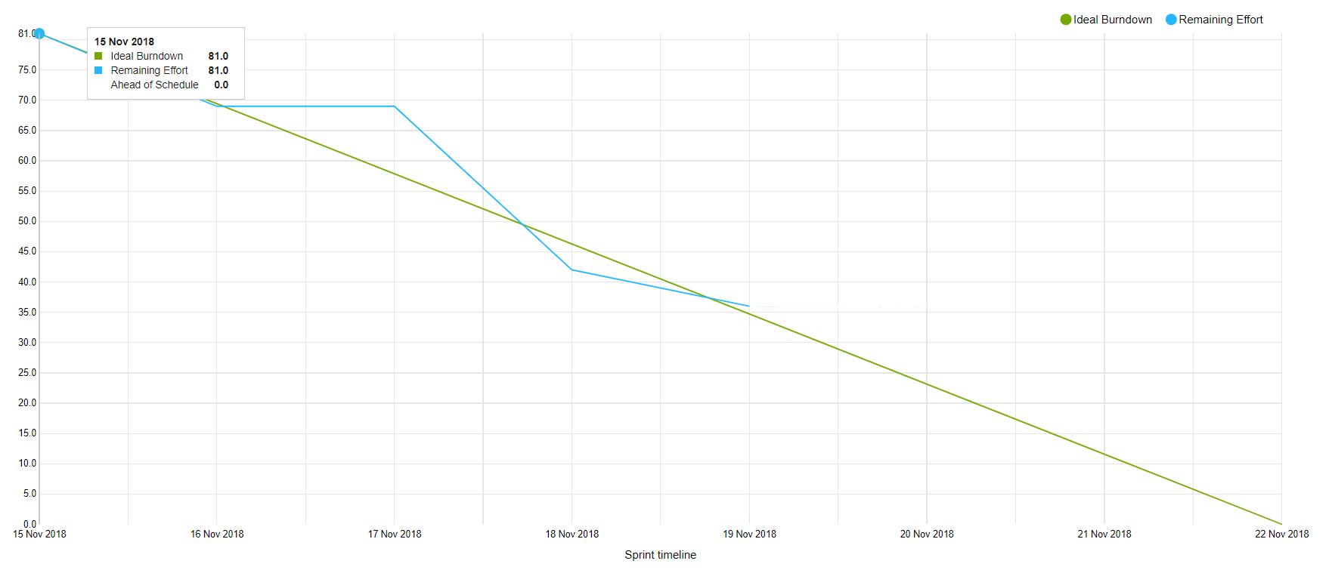

**What is done:**

* Tests CRUD controller for bookstore
* Website : book details page
* Database : search and details for institutions -> communication
* Class diagram library updated
* Database : user tables + hibernate
* Database server : registration request
* Book service : registration communication with Database
* Use case diagram
* Database : checking book by ISBN
* Book service : handle registration request -> POST
* Library : documentation od API
* Library : change to new URI
* Book service : diagram updated
* Website : navbar

**What is in progress:**

* Website : admin page, registration page, connection with API
* Library : correct book details request
* Library : update documentation
* Database : tests for request handling
* Process report
* Bookstore : registration tests, controller
* Database documentation
* Web service documentation

**New tasks:**

* Database : library book details, bookstore book details
* Database : update connection of book details for institution, add institution name

**Sprint 4 (25.11)**

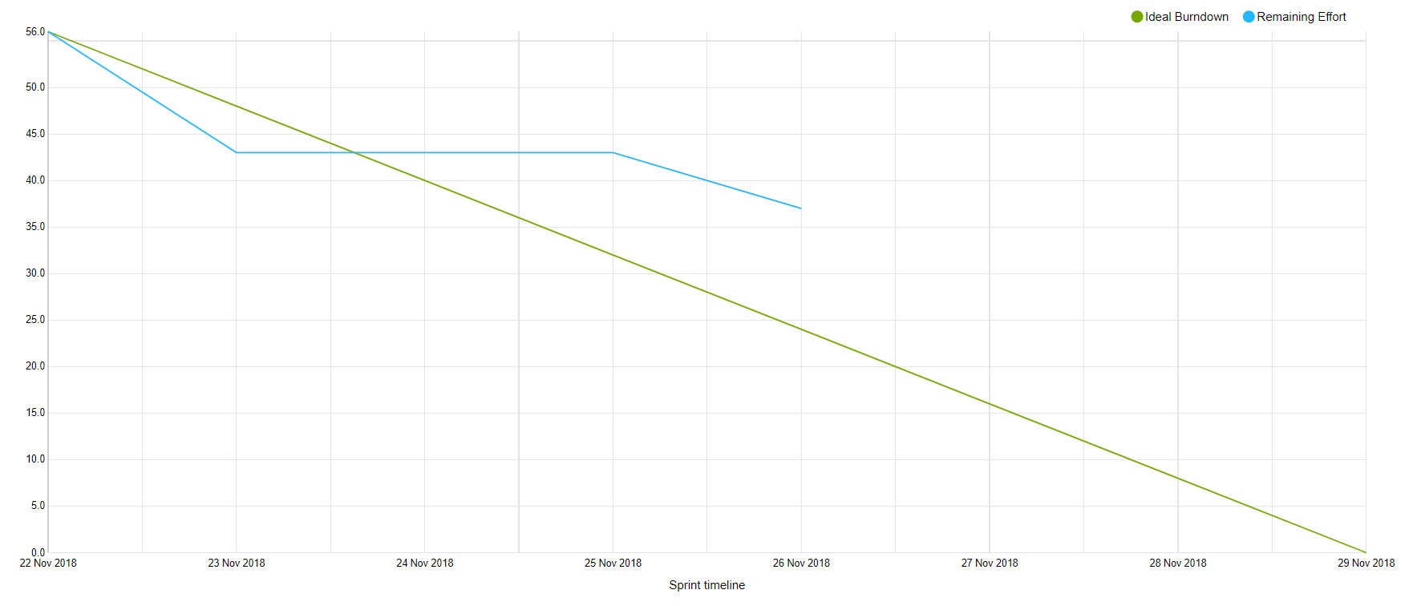

**What is done:**

* Error in database are fixed
* Use case
* Book service : request for borrowing the book from library, request for buying the book from the bookstore
* Database : order table
* Database : documentation updated
* Database : hibernate
* Database : add borrow order, buy order
* SSL
* Documentation of security

**What is in progress:**

* GUI : website -> connect both admins, list of libraries and books details for guest/customer, registration page connect form with API
* GUI : advanced search
* Fix search and advanced search
* Class diagram update
* Sequence diagram update
* Communication : borrow order, buy order
* Web service documentation update
* Hibernate query builder

**New tasks:**

* SSL
* Documentation of security
* Fix search

**Sprint 5 (3.12)**

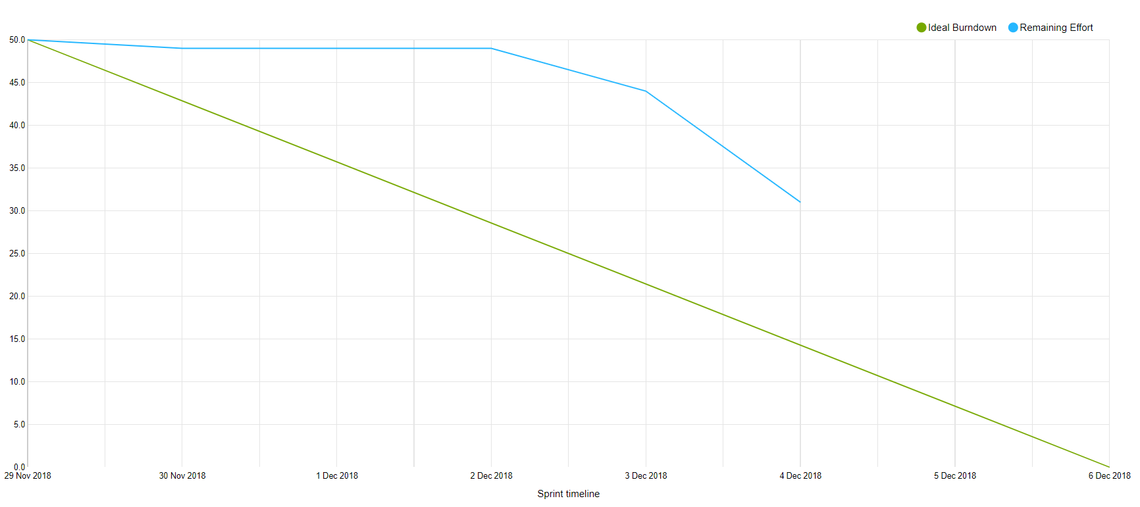

**What is done:**

* Website : list of libraries and books in book details for guest / customer – layout
* Web services doc updated
* Find out how to make login
* Document login
* Database and Services add password
* Database add admins
* Sequence diagram login
* Web service : login layout
* Implement authentication

**What is in progress :**

* What is the progress : Website : connect both admins, connect book details list to API, registration page connect to API
* Website : storing cookies, adding cookie in request
* Website : changing layout on login
* Database documentation
* Change process report
* Document authentication
* Test library authentication
* Login encryption
* Add checking session key before request in Bookstore, Book service and Library

**DAILY LOG**

**Sprint 6**

**6.12:**

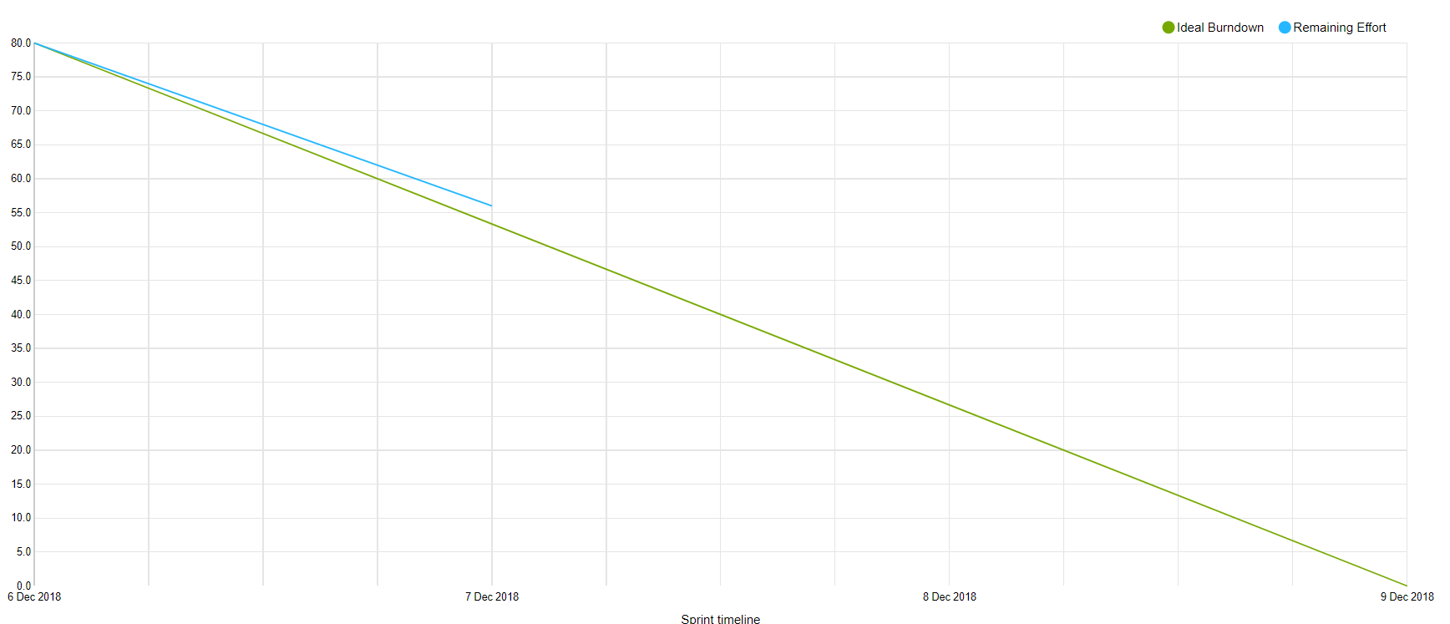

**What is done:**

* website: registration page JS connect form with API
* document of authentication in book service and bookstore
* update library diagram
* add checking session key before request – library
* add checking session key before request – bookstore, book service
* database: handle confirm order for bookstore + communication
* use case

**7.12:**

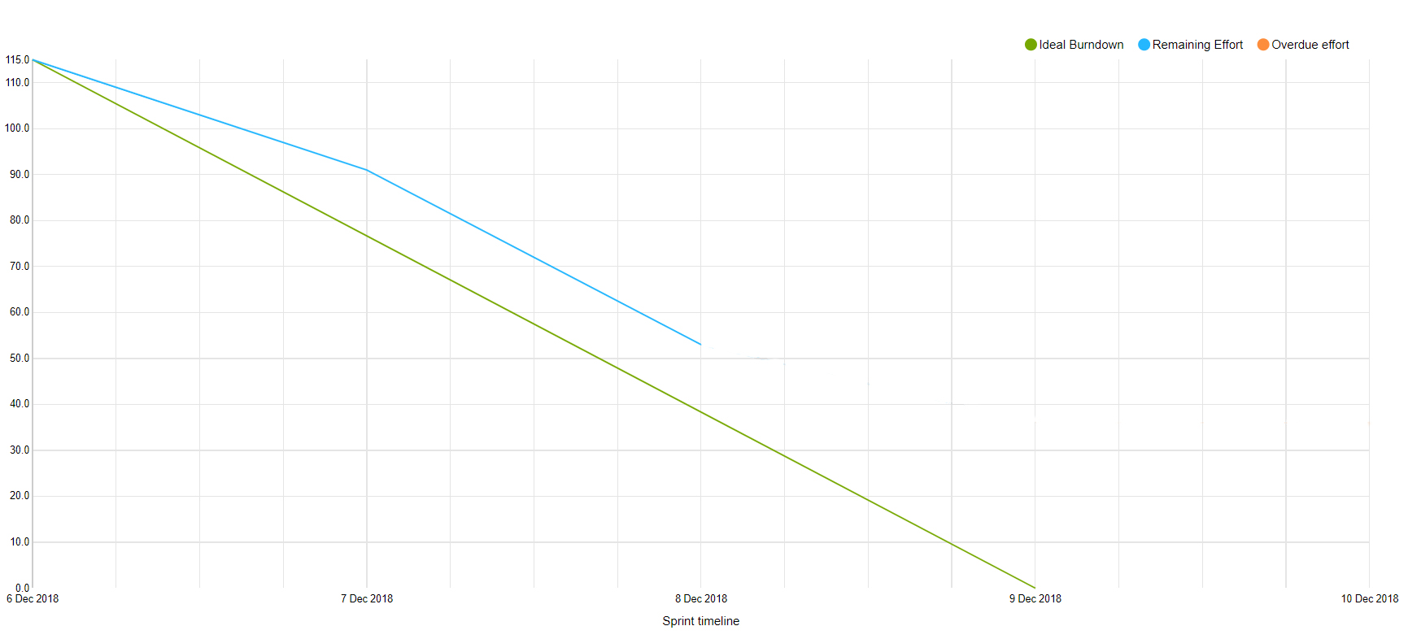

**What is done:**

* login encryption
* database documentation
* database diagram updated
* authentication for bookstore document
* website : login storing cookies, adding cookie in request
* process report

*\*new tasks added*

**8.12:**

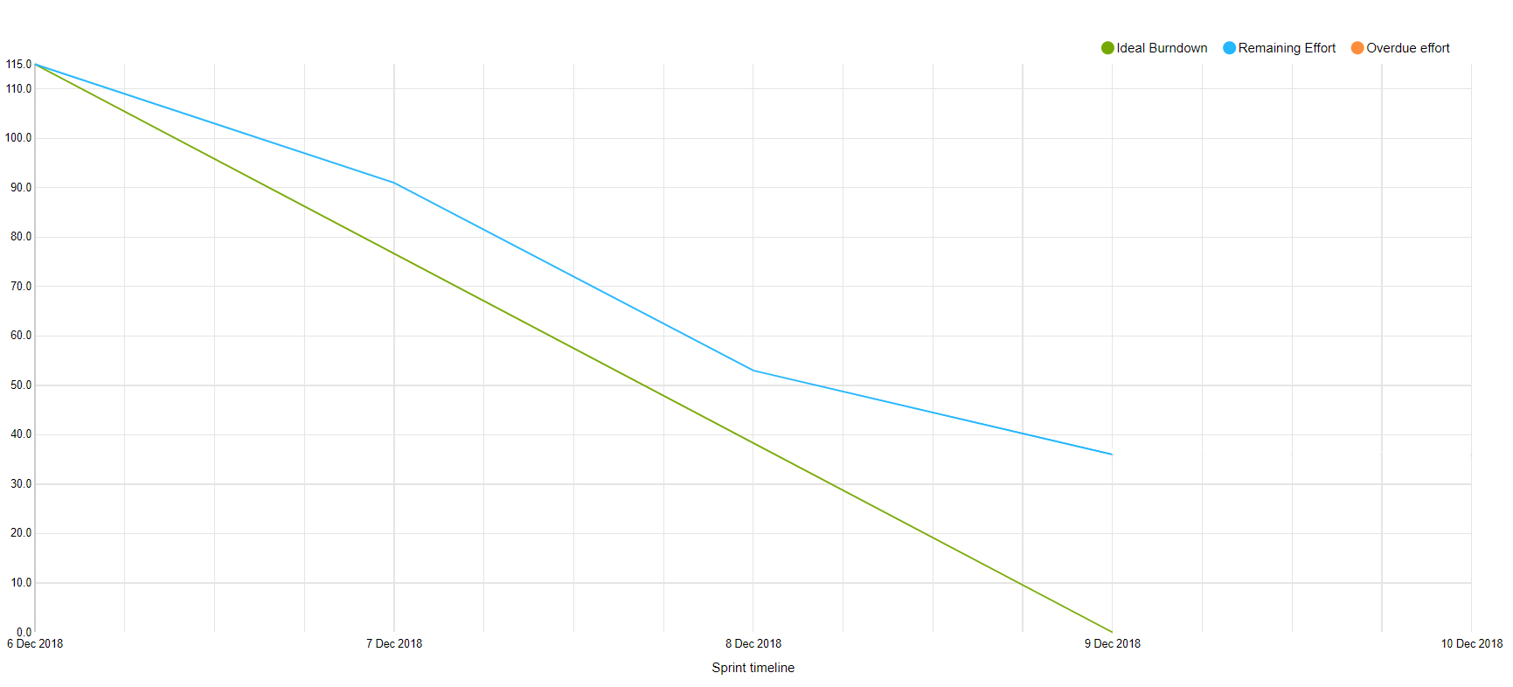

**What is done:**

* Database handle return book request + communication
* Update communication diagram
* Bookstore – get unconfirmed orders request
* Database handle get orders + communication
* Library authentication document
* Use case
* Library get orders – not returned book request
* Library return book request

**Sprint 7**

**9.12:**

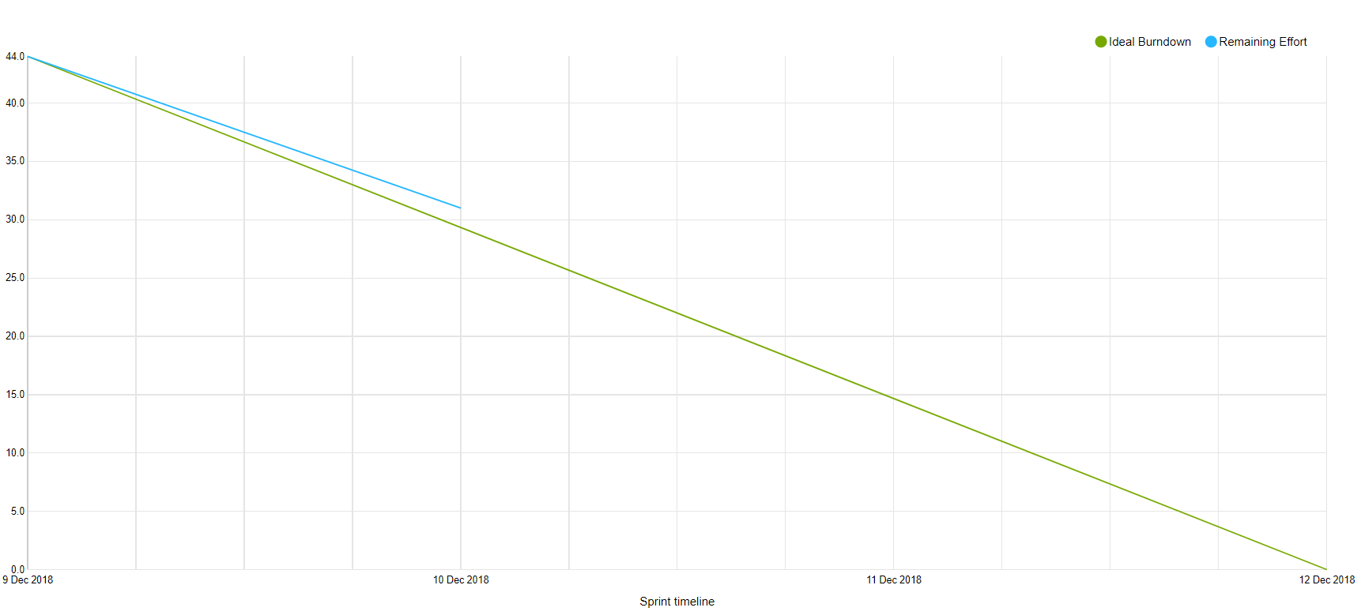

**What is done :**

* Website : connect bookstore admin to API
* Website : navbar changing on login
* Website : connect advanced search to API
* Bookstore : confirm order manual test
* Library : return book manual test

**10.12:**

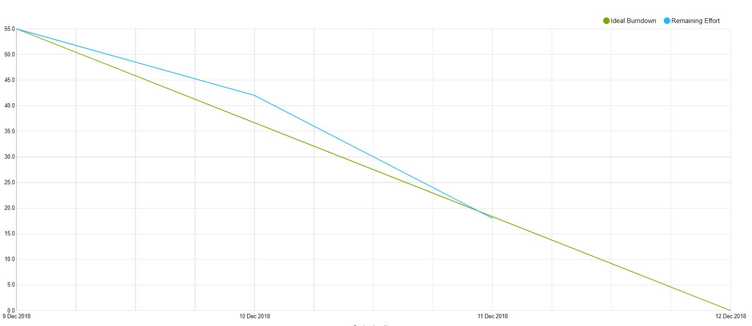

* Security documentation – analysis
* Website : library admin – layout for order
* Website : library admin orders connect to API
* Website : Advanced search corrected

**11.12:**

**Sprint 8**

**12.12:**

**13.12:**

**14.12:**